

**Secretary:**

Miss Annabel Mason

Clark House Farm, Embsay, Skipton, North Yorkshire

BD23 6PP

Tel: 07792 198346 Email: [oddacres@msn.com](mailto:oddacres@msn.com)

North East Limousin Breeders Club

**Chairman:**

Mr Karl Suddes

Dairy cottage, South Farm,

Cornsay,

Durham. DH7 9EL

Tel: 07980707454

[Karl_suddes@hotmail.com](mailto:Karl_suddes@hotmail.com)

**September Newsletter**

On Sunday 26th August members had a brilliant day out despite the wet and windy weather, starting at John Murrays, Glebe farm, looking round his commercial herd and pedigree British Blues and Haneve Limousin herd.

A judging competition was held with members judging a pen of 4 Limousin heifers, 4 prime lambs and 4 mule gimmers with John Mason of the Oddacres herd as master judge and a guess the weight of the bull competition, the results were as follows -

Ladies Gentlemen

1st Elaine Murray 1st John Swales

2nd Emily Wilson 2nd Keith Wilson

3rd Annabel Mason 3rd Matthew Watson

Guess the weight of the bull was won by John Hildreth

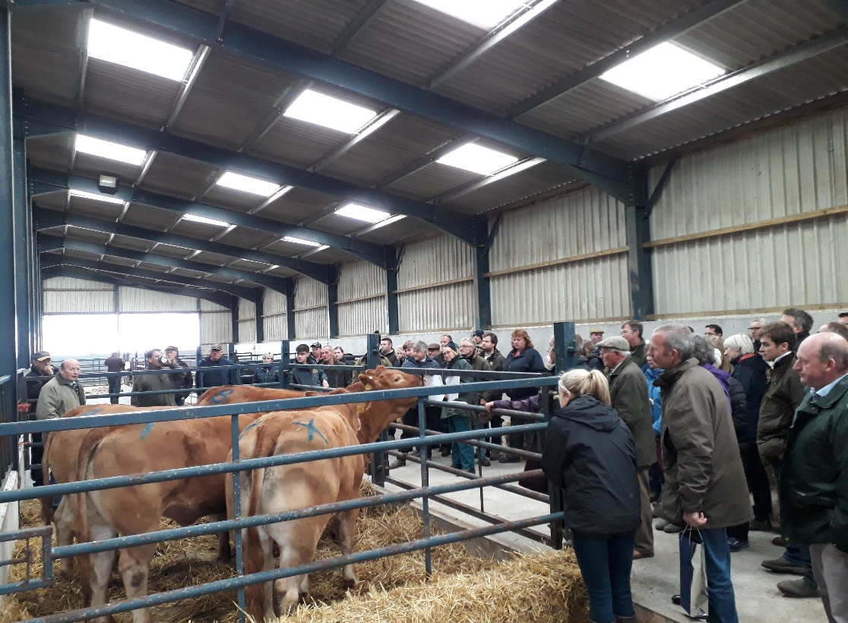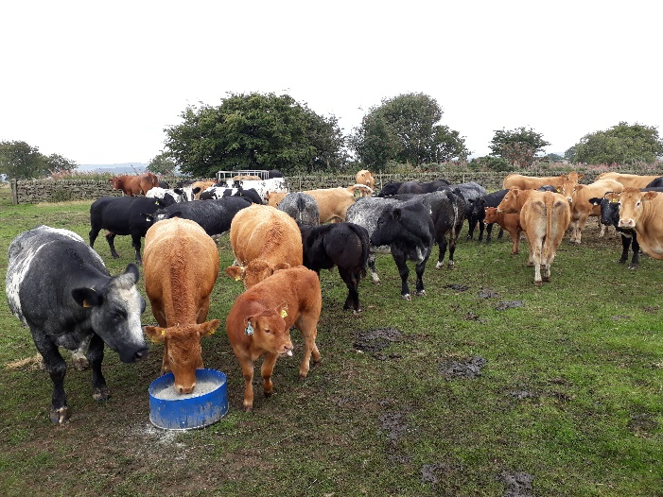

Members then enjoyed a hogg roast before travelling onto Willy Barron’s at Morrow Edge Farm, home to the Barron’s herd. Members enjoyed looking round the pedigree Limousin cattle and there was another judging competition of 4 Limousin bulls and 4 Limousin heifers.

The results were –

Ladies 1st – Billie Wilson

Gentlemen 1st – Richard Priestley

Both scoring full marks. This was kindly judged by Helen Claxton. Members then enjoyed afternoon tea.

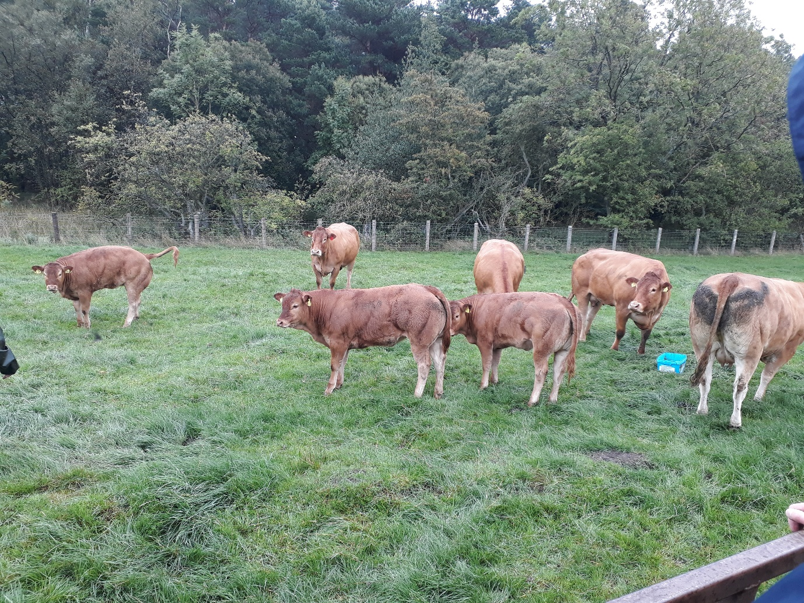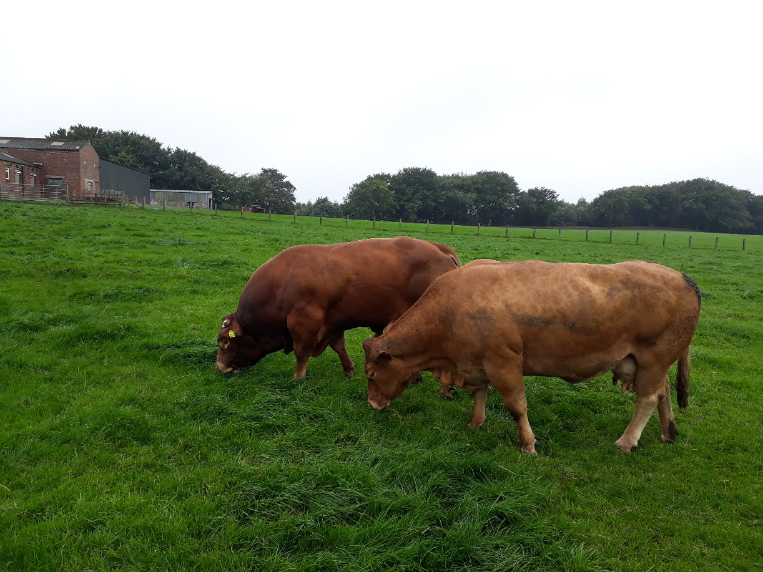

**Thank you to the Murray family and the Barron family for an excellent day.**

**Annual General Meeting – Due to the unavailability of the pub the AGM meeting will be held before the start of the annual dinner at 7pm at The Bridge Inn, Walshford.**

**\*\*\*Club Dinner\*\*\***

This year’s annual dinner and herd competition results will be held on Saturday 6th October at The Bridge Inn, Walshford at 7pm. Once again tickets are £22 per person, with a roast dinner buffet. PLEASE NOTE anyone requiring Vegetarian option must let Phyllis know when booking their tickets. Rooms are available, but you must let Phyllis know as soon as possible to get them booked in time.

***The annual tombola will also take place, so prizes will be required***

For tickets please contact Phyllis on 07808916636. PLEASE MAKE SURE ANY TROPHIES ARE RETURNED FOR THE HERD COMPETITION.