

**Chairman:**

Mr Karl Suddes

Dairy cottage, South Farm,

Cornsay,

Durham. DH7 9EL

Tel: 07980707454

[Karl_suddes@hotmail.com](mailto:Karl_suddes@hotmail.com)

**Secretary:**

Miss Annabel Mason

Clark House Farm, Embsay, Skipton, North Yorkshire

BD23 6PP

Tel: 07792 198346 Email: [oddacres@msn.com](mailto:oddacres@msn.com)

North East Limousin Breeders Club

**Newsletter- November 2018**

**Bull and Heifer Derby**

On 24th September Alan Morgan of the Almande herd judged the North East Bull and Heifer derby at Nidderdale show.

Results were as follows –

Bulls

1st J & S Cooper with Tomschoice Notorious

2nd T, E & M Priestley with Prietec Nacho

3rd A & J Atkins with Mountainstorm Nashville

Heifers

1st T, E & M Priestley with Prietec Nutmeg

2nd J & S Cooper with Tomschoice Nymph

On Saturday 6th October almost 90 members attended the annual dinner and prize giving at The Bridge Inn, Walshford. Before the meal the Annual General Meeting was held with Karl Suddes remaining as chairman, Will Barker as vice chairman, Annabel Mason as secretary and Phyllis Orton remaining as treasurer for the next year.

All agreed the subscriptions will remain at £20 per heard for 2019.

A lovely meal was enjoyed by all and then Chairman, Karl Suddes gave his club report on the events and visits of 2018.

Andrew Burnett of the Spittalton herd then gave out the herd competition results.

Congratulations goes to Willy Barron of the Barrons herd for winning the champion overall herd for the second year in a row! Please find attached a full copy of the results.

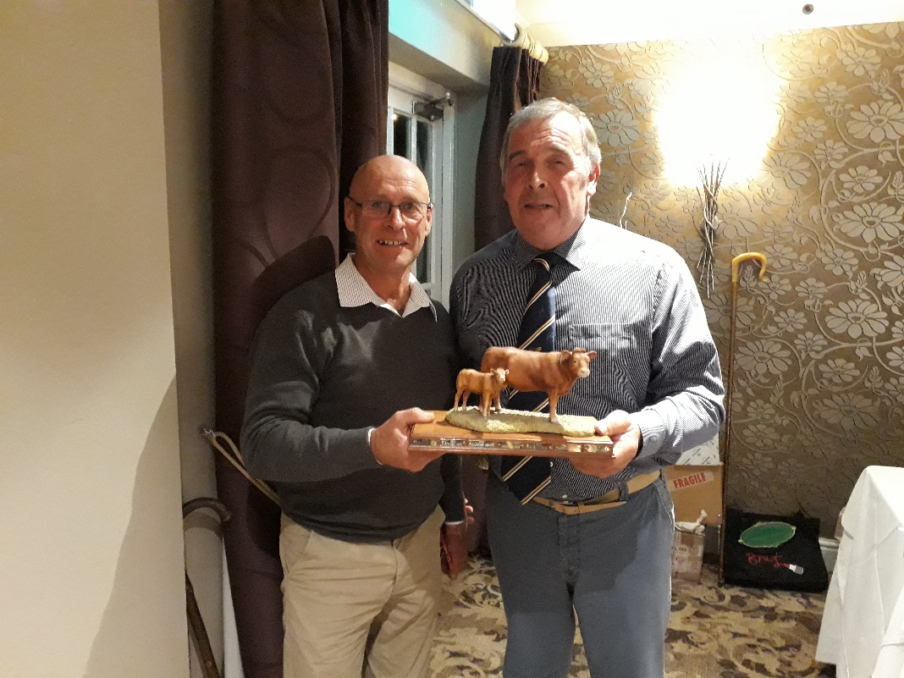

Final committee meeting of the year to be held on 3rd December at High Farm, Hopperton at 7.30pm

**IF ANYONE HAS ANY IDEAS OF FARM VISITS OR OTHER ACTIVITIES PLEASE LET KARL OR ANNABEL KNOW**

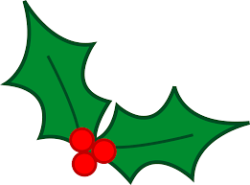Thank you to everyone for your support towards the club and all from the committee wish everyone a happy Christmas and all the best for 2019! You will receive a January newsletter and programme in the new year.