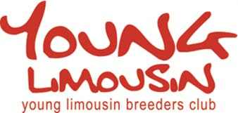

ANNUAL MEMBERSHIP FORM 2018
Annual Membership is £10.00 (£8 + VAT), which runs from 1st January to the 31st December, annually, with submission of this membership form.
Subscriptions contribute towards the running of the YLBC fund, events, prizes and administration costs both to run the club activities and for entries to some events.
Only fully paid up Members can participate in the advertised activities and competitions.
Name:
Address:
Post Code:
Telephone: |  | Mobile:
Email:
Date of Birth:
Signature: |  |  | Date:

Cheques should be made payable to: “Young Limousin Breeders Club”, and returned along with this form to:
YLBC
British Limousin Cattle Society
Concorde House
Leamington Spa
Warwickshire
CV32 5JG
Email : ylbc@limousin.co.uk or natalie.cormack@btconnect.com

