South West Limousin Spring Show & Sale at Holsworthy – Wednesday 26th May
Top Price £4200 twice for the Killerton Herd!
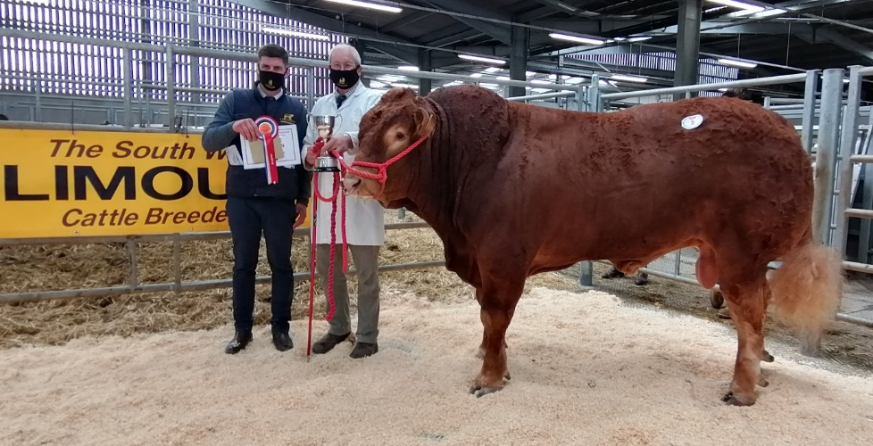
Patrick Greed with Killerton Panda & Barnaby Bridgman - sponsor
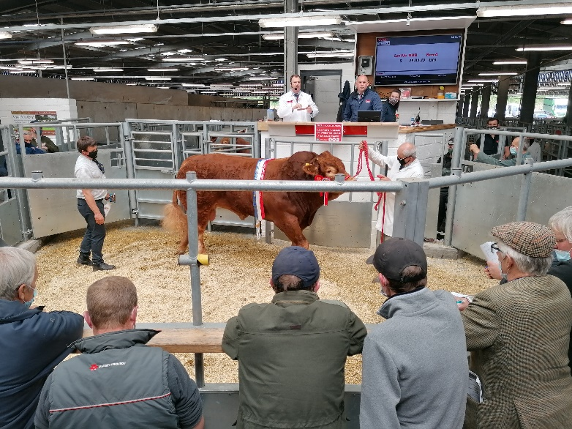
After a good season of selling Breeding Bulls this year, the Sale at Holsworthy met likewise with the Supreme Champions Killerton Panda selling to 4000 gns from Patrick Greed, judged by Arthur Stanbury of Launceston. Panda an April 2019 bull was sired by Ampertaine Lawson

The Luxton Family from the Josh Herd, Bude took the Reserve Supreme Championship with Josh Percy,
Nicely achieved with Mark & Dee Luxton and their four girls living locally to Holsworthy market.
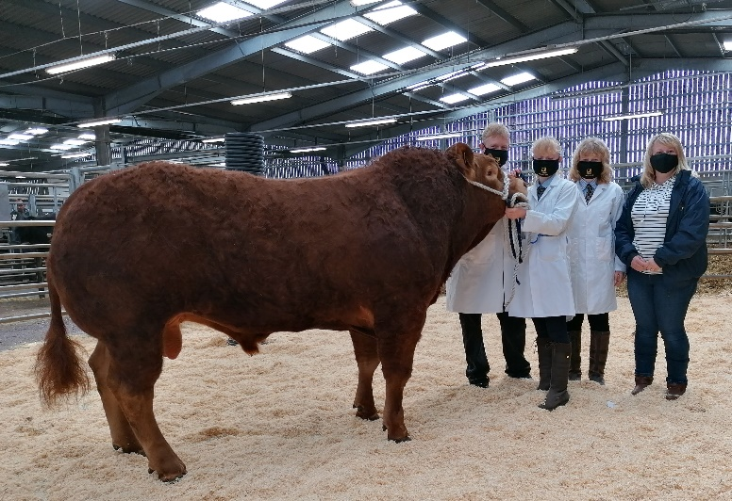
Josh Percy with Mark & Dee Luxton and their twin daughters Chloe & Jade
Again at 4000 gns was Killerton PeepingTom born November 2019 and carrying 2 copies of the F94L gene. PeepingTom came 1st in his Class and is sired by Goldies Jeff. Loosebeare Rolo achieved 3500 gns having been placed 3rd in his class. Rolo born February 2020 carries the F94L/Q204x gene and is sired by Ampertaine Jeronimo. Loosebeare Prized, a 2nd Prize winner and sired by Loosebeare Master sold to 2900gns
Results as follows:
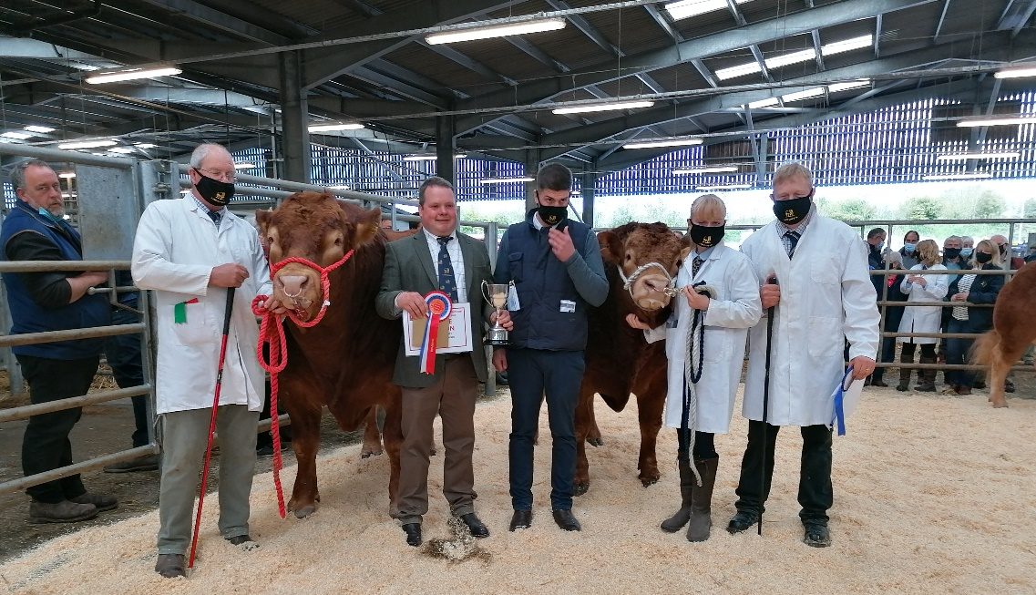
Supreme Champion
Killerton Panda
Mr & Mrs PW & SM Greed
Reserve Champion
Josh Percy –
Mr MA & Mrs D Luxton
Bulls over 2 Years
1st - Killerton Panda
Mr & Mrs PW & SM Greed
2nd - Josh Percy
Mr MA & Mrs D Luxton
3rd – Josh Powerhouse
Mr MA & Mrs D Luxton
Bulls Under 2 Years
1st - Killerton PeepingTom Mr & Mrs PW & SM Greed Champion & Reserve with Judge Arthur Stanbury & sponsor Barnaby Bridgman
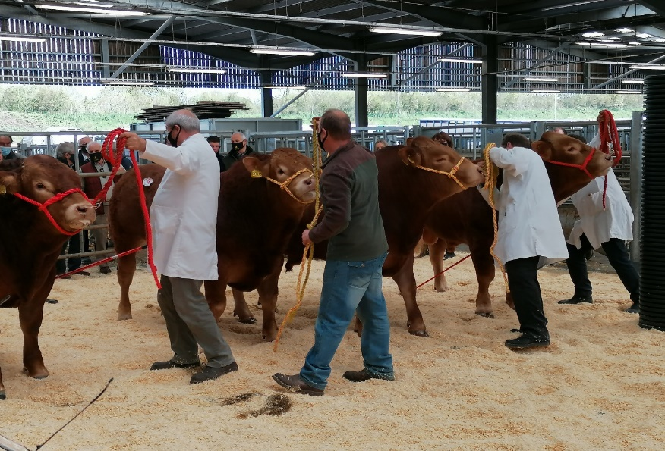
2nd - Loosebeare Prized
EW Quick & Sons
3rd - Loosebeare Rolo
EW Quick & Sons
4th - Killerton Ray
Mr & Mrs PW & SM Greed

Cows Incalf
1st Mynach Odessa – Mr A Churches
2nd Mynach Mitsi – Mr A Churches
3rd Mynach Olive – Mr A Churches

Included with the Sale were Embryos and Semen for Sale. It was great to have Anne Wheeler from the dispersed Rosecroft Herd and Carolyn Runnalls from Newton Abbot taking part!
Thank you to Harry Parker, the British Limousin Cattle Society Chairman and South West Representative for coming down to Holsworthy and to our Judge Arthur Stanbury. With the Show & Sale being moved to Exeter this year, then being cancelled due to Covid restrictions, we had to last minute change our plans to make the May Sale at Holsworthy a Show.
Thanks goes to the Society, Mark Bromell and the Team at Kivells and all Sponsors, not forgetting the South West Club members who entered their Limousin Cattle, Embryos & Semen!

